R. Reports Menu: 6. Combined Marriage or Civil Union Index (8.5x8)

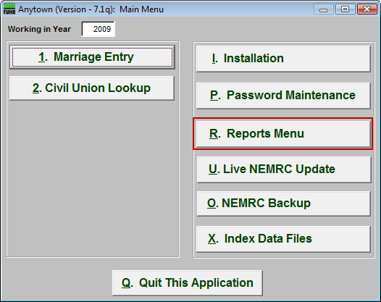
Click on “R. Reports Menu” from the Main Menu and the following window will appear:

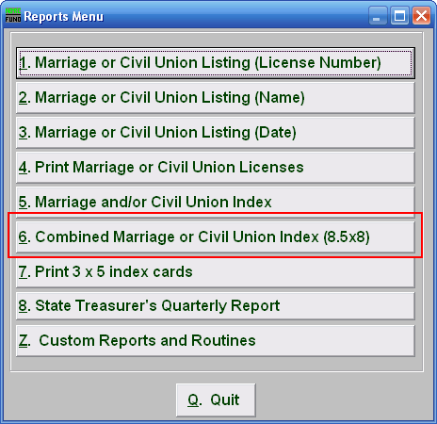
Click on “6. Combined Marriage or Civil Union Index (8.5x8)” from the Reports Menu and the following window will appear:

Combined Marriage or Civil Union Index (8.5x8)

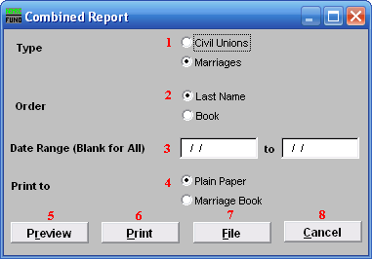
- Civil Unions OR Marriages: Click on the circle next to the Type you want the report to be on.

- Order: Click on the circle next to the order you want the report to print in.

- Date Range (Blank for All): Enter the date you wish to start with and the date you wish to end with. Leave blank for all.

- Print to: Click on the circle next to the kind of paper you are printing on.

- Preview: Click this button to preview. Refer to GENERAL PREVIEW for more information.

- Print: Click this button to print. Refer to GENERAL PRINTING for more information.

- File: Click this button to save on this computer. Refer to GENERAL FILE for more information.

- Cancel: Click “Cancel” to cancel and return to the previous screen.

